Q1.
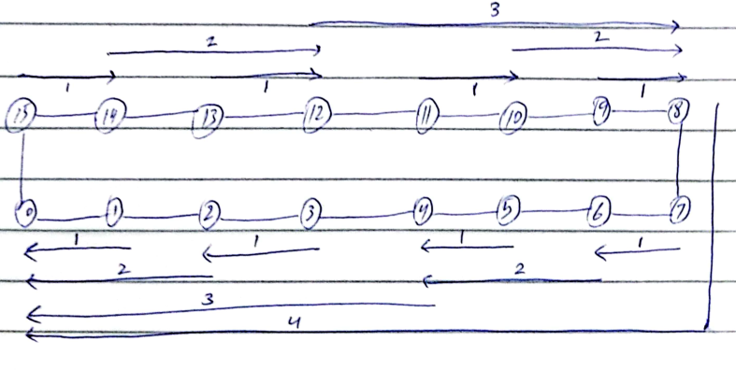

Q2.

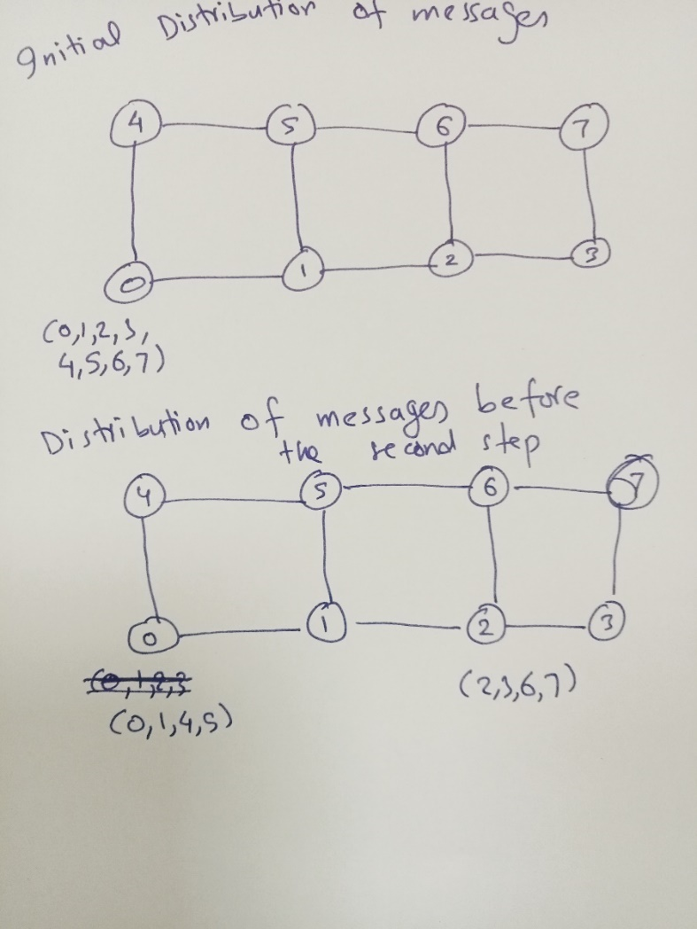

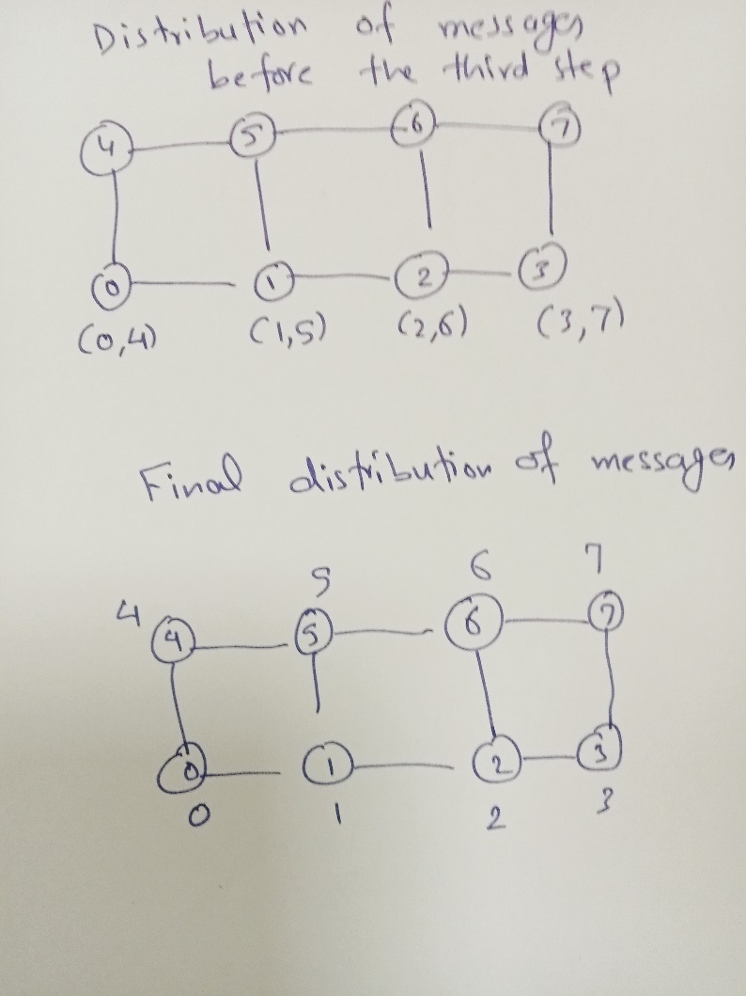

Communication cost (first step) = t_{s} + 4m t_{w}
Communication cost (second step) = t_{s} + 2m t_{w}
Communication cost (third step) = t_{s} + m t_{w}
Total communication cost = 3t_{s} + 7m t_{w}

Q3.

Output:

At thread: 0 iteration: 0
At thread: 0 iteration: 1
At thread: 0 iteration: 2
At thread: 0 iteration: 3
At thread: 1 iteration: 4
At thread: 1 iteration: 5
At thread: 1 iteration: 6
At thread: 1 iteration: 7
At thread: 2 iteration: 8
At thread: 2 iteration: 9
At thread: 2 iteration: 10
At thread: 2 iteration: 11

4 10 18 28 40 54 70 88 108 130 154 180

Q4.
Solution:
- Output=45
- Sum variable:
- Each thread computes its local thread_sum independently.
- When all iterations are complete, each thread enters the #pragma omp critical section to add its thread_sum to the shared variable sum.
- Since the critical section is synchronized, only one thread can update sum at a time, ensuring the correct final result.

Q5.
